# Assignment No 2

## Simple Calculator

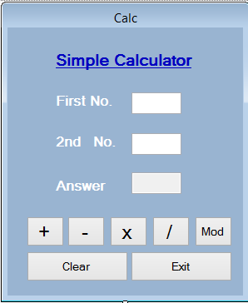**Design Time**

**Run time**

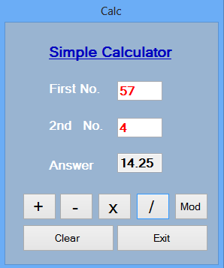

**Coding**

Public Class frmCalc

Private Sub btnPlus_Click(sender As Object, e As EventArgs) Handles btnPlus.Click

txtAnswer.Text = Val(txtFirst.Text) + Val(txtSecond.Text)

End Sub

Private Sub btnMinus_Click(sender As Object, e As EventArgs) Handles btnMinus.Click

txtAnswer.Text = txtFirst.Text - txtSecond.Text

End Sub

Private Sub btnMultiply_Click(sender As Object, e As EventArgs) Handles btnMultiply.Click

txtAnswer.Text = txtFirst.Text * txtSecond.Text

End Sub

Private Sub btnDivide_Click(sender As Object, e As EventArgs) Handles btnDivide.Click

txtAnswer.Text = txtFirst.Text / txtSecond.Text

End Sub

Private Sub btnMod_Click(sender As Object, e As EventArgs) Handles btnMod.Click

txtAnswer.Text = txtFirst.Text Mod txtSecond.Text

End Sub

Private Sub btnClear_Click(sender As Object, e As EventArgs) Handles btnClear.Click

txtFirst.Text = ""

txtSecond.Text = ""

txtAnswer.Text = ""

txtFirst.Focus()

End Sub

Private Sub btnExit_Click(sender As Object, e As EventArgs) Handles btnExit.Click

Me.Close()

End Sub

End Class

Specification:

Software Specification: (NetBeans 8.2)

A free, open-source Incorporated Improvement Climate for programming planners. You get every one of the assets you need to make proficient pc, organizations, web, and portable applications with Java phrasing, C/C++, and surprisingly amazing 'dialects' like PHP, JavaScript, Cool, and Ruby... NetBeans IDE is not difficult to place in and utilize straightforwardly out of the case and works on numerous frameworks like Windows, Macintosh operating system, Solaris, and Linux. You can appreciate the recorded beneath highlights alongside numerous others by playing out the NetBeans IDE 8.2:

Out of the box

Java Editor

Java EE

HTML5, JavaScript, and CSS3

Internet of Things

Profiler

Git and Mercurial

Software Design:

Utilizing the IDE (Integrated Development Environment) makes improvement works simpler in light of the fact that there's a great deal of mechanization, idea, autocomplete, simple to run, and so on NetBeans is an open-source programming improvement project with a functioning local area of teaming up clients and engineers. Let beginning by start your NetBeans IDE. I use JFrame for this task for the benefit of GUI (Graphical User Interface Experience).